LAB – 6

1. Reverse a Number Using a While Loop

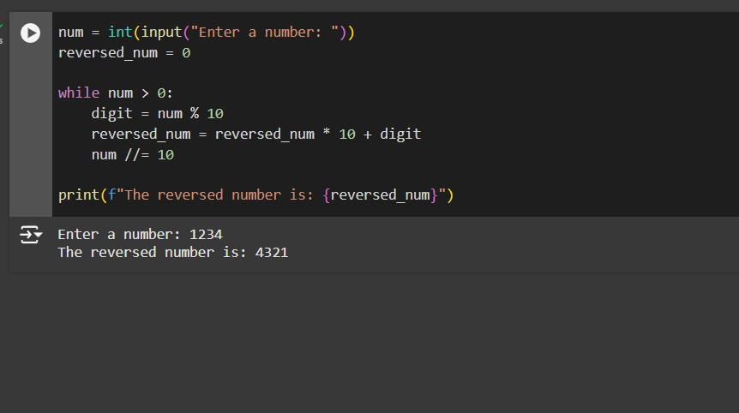

1. Check if a Number is a Palindrome

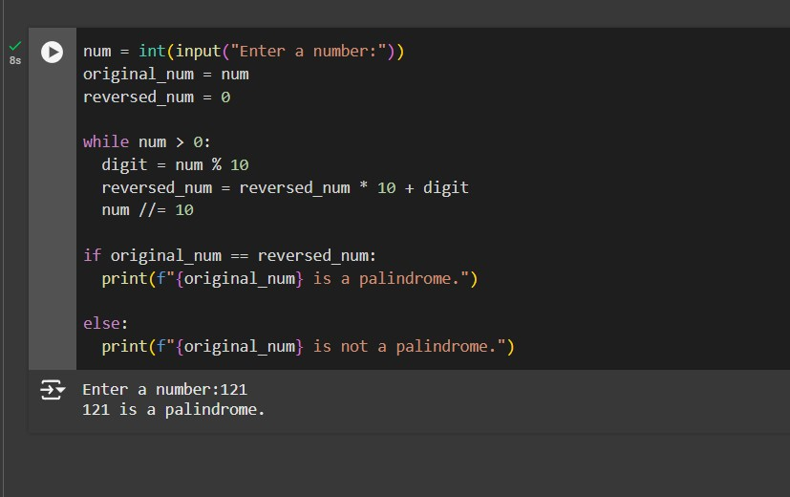

1. Find the Factorial of a Given Number Using a While Loop

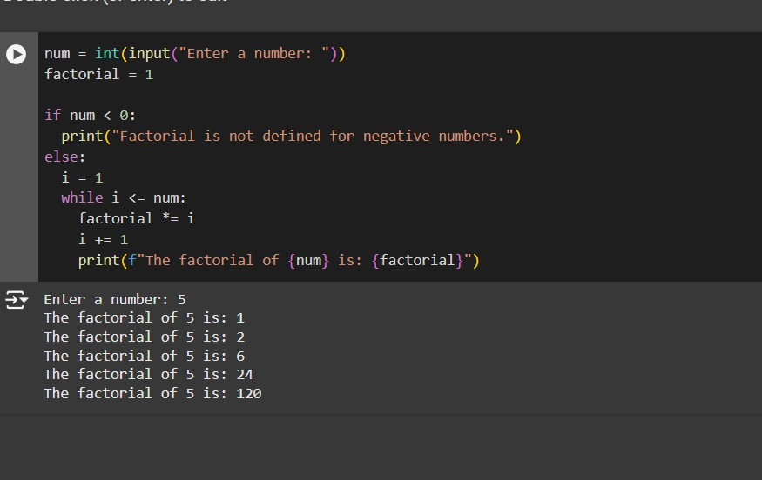

1. Sum Numbers Until User Enters 0

